1. **OBJECTIVES**

See the requirements document.

Note: we chose to do the PCB layout of lab 5 (piano lab)

1. **HARDWARE DESIGN**
   1. See the Samsung Galaxy Note i717/T879 Replacement Battery info sheet

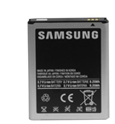

*Figure ####: Samsung Galaxy Note i717/T879 replacement battery*

* 1. See the Hammond 1519E datasheet

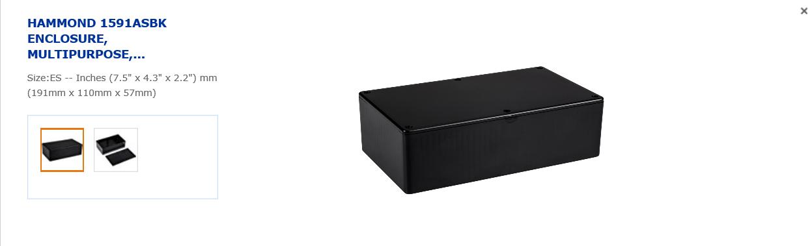

*Figure ####: Hammond 1519E box (standard box provided by Dr. Valvano)*

* 1. New component we created

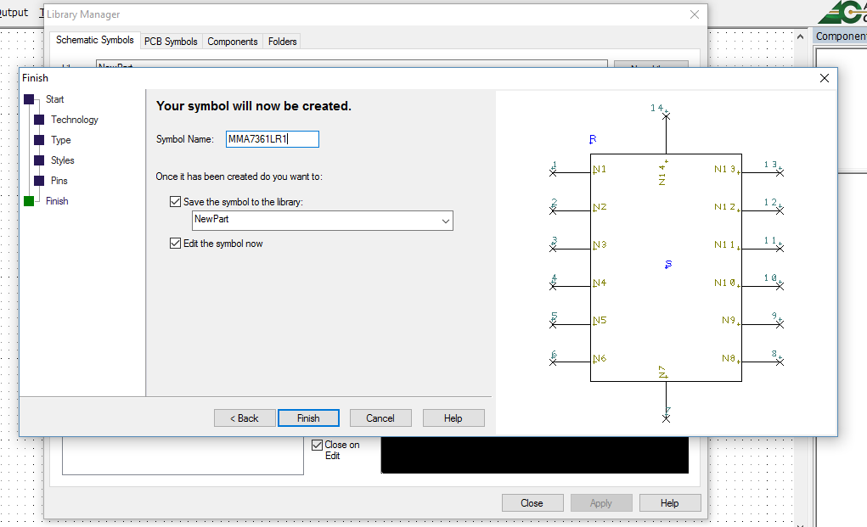

*Figure 1: MMA7631LR1 (accelerometer) component in the Schematic Symbols editor*

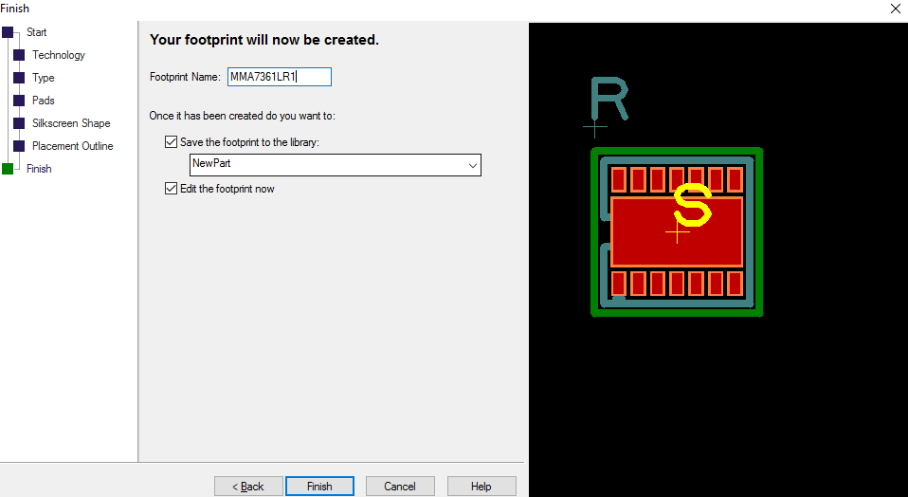

*Figure 2: MMA7631LR1 (accelerometer) component in the PCB Symbols editor*

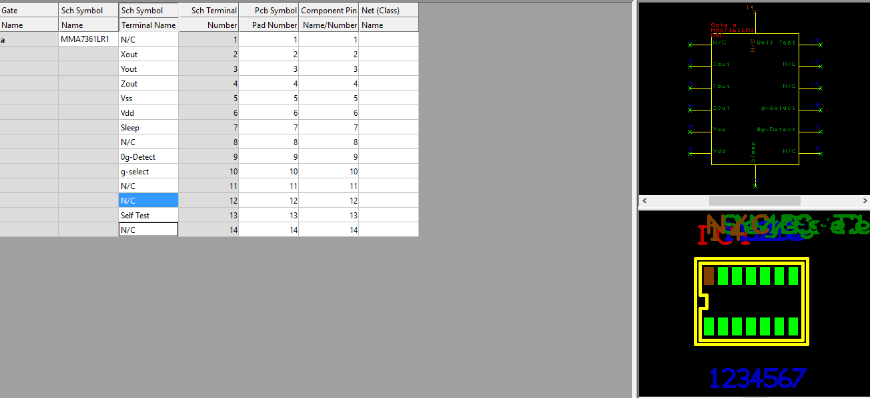

*Figure 3: MMA7631LR1 (accelerometer) component in the Components editor*

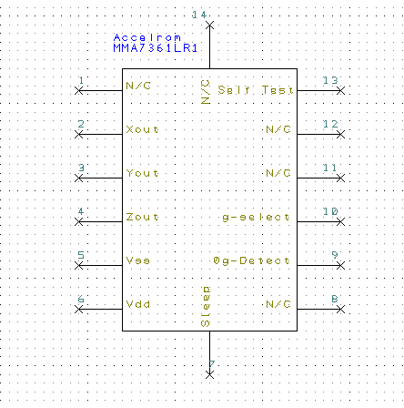

*Figure 4: shows that our component can be added from the library to an SCH file*

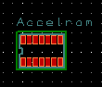

*Figure 5: shows that our component can be added from the library to a PCB file*

* 1. Mechanical drawings
  2. See the schematic file of our final circuit
  3. Cardboard mockup of the PCB layout

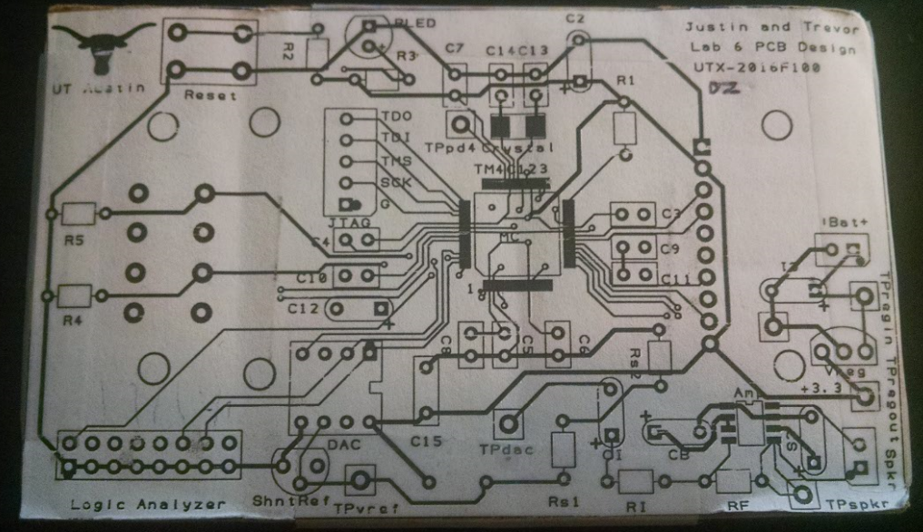

*Figure ####: top copper/silk on top*

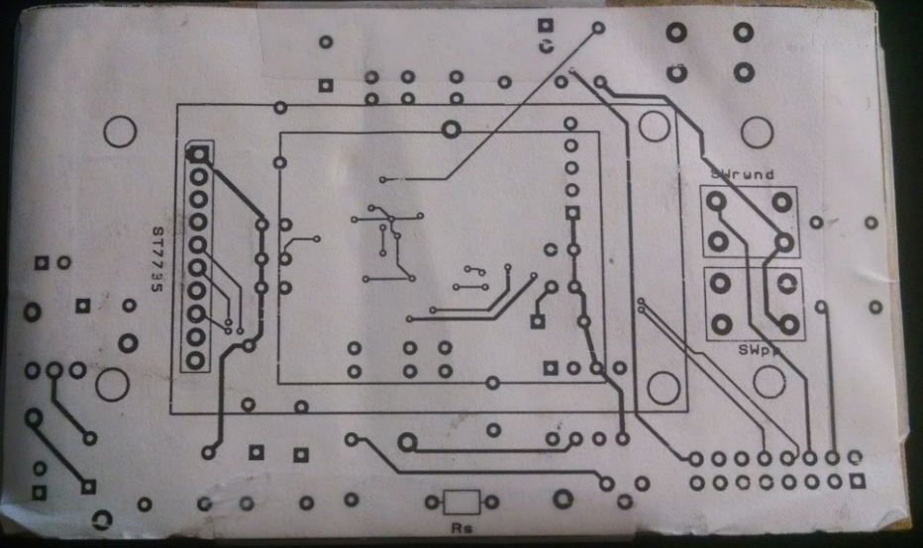

*Figure ####: bottom copper/silk on bottom*

1. **SOFTWARE DESIGN**

None

1. **MEASUREMENT DATA**
   1. See the Lab6_BOM excel file. Didn’t add current yet
   2. Our project requires a maximum current input of 90mA. With a battery capacity of 2500 mAH, our system will be able run for at least 27.7 hours (longer if the system doesn’t draw the full current at every point in time). Furthermore, the voltage output will sufficiently power our regulator.

We chose a phone battery because it is much slimmer and less bulky than other batteries, allowing us to mount the battery in just about any kind of orientation. Also, this particular battery is relatively inexpensive compared to other Li-Ion batteries of the same size and capacity.

1. **ANALYSIS AND DISCUSSION**
   1. Explain the testing procedure you would suggest for the system